**MODOC COUNTY OFFICE OF EDUCATION**

**ADMINISTRATIVE ADVISORY COUNCIL (AAC)**

**POLICIES & RESOLUTIONS**

**TABLE OF CONTENTS**

**Policies**

Policy 1 Admission of Local Educational Agencies to the Modoc County SELPA

(adopted 1-19-01)

Policy 2 Least Restrictive Environment (LRE) Policy (adopted 1-19-01)

Policy 3 Provision of Special Education Services to Students Voluntarily Enrolled in Charter Schools (adopted 1-19-01)

Policy 4 Modoc County SELPA Facilities Policy & Procedures (adopted 1-23-02)

## Policy 5 Photocopying Costs in the Districts (minutes from 2-23-04 meeting, agreed upon 6-14-02)

Policy 6 Rental Agreements for Special Education Classrooms (memo 3-04-03)

Policy 7 Independent Educational Evaluations Policy (adopted 4-28-03)

Policy 8 SELPA Monitoring Responsibilities (adopted 12-17-03 / revised 9-25-07)

LAR #1 – Local Administrative Regulation – SELPA Monitoring

Policy 9 Modoc County SELPA Behavioral Intervention (adopted 9-26-06, revised and readopted 12-14-09)

Policy 10 Manifestation Determination Federal Assurance Administrative Regulation (adopted 2-13-07)

Policy 11 Provision for Ongoing Review of Programs (adopted 4-15-08)

Policy 12 Animals at School (adopted 12-14-09)

Policy 13 Adults in Correctional Facilities (adopted 12-13-11)

Policy 14 Certificates of Completion (adopted 02-14-12)

Policy 15 Modoc County SELPA Attendance Procedures for Special Education Students (adopted 06-12-12, revised and readopted 06/24/14)

Policy 16 Modoc County SELPA Maintenance of Effort (MOE) (adopted 02-12-13)

Policy 17 Modoc County SELPA Graduation from High School (adopted 10-08-13)

Policy 18 Modoc County SELPA ADA Transfer for Special Education Students (adopted 6/24/14)

**Resolutions**

Resolution 01-09 Approval of Behavioral Intervention Plans [Hughes Bill] Mandated Cost Claim Settlement and Agreement to Waive Future Claims

# MODOC COUNTY SELPA – Policy #1

**ADMISSION OF LOCAL EDUCATIONAL AGENCIES**

**TO THE MODOC COUNTY SELPA**

Any public school district or county office of education, hereinafter referred to as a local education agency (LEA) located within the State of California may apply to the SELPA Administrative Advisory Council (AAC) to become a member of the SELPA. Application must be made to the SELPA on or before February 1 of the school year preceding the school year in which the LEA anticipates operating as a member within the SELPA. LEA member status will not become effective prior to July 1 of the year in which final approval was granted. Once granted membership, the LEA will participate in the governance of the SELPA in the same manner as all other LEA members in the SELPA.

The applicant LEA will be deemed a member of the SELPA if the Administrative Advisory Council determines that the LEA has met all requirements to be included as a member LEA as specified in this policy and the Local Plan. The applicant LEA will meet all other applicable requirements, if any, from the California Department of Education and the current SELPA to which the LEA belongs.

The SELPA requirements include an agreement to:

* Provide assurances that all eligible individuals with disabilities (ages birth to 22) shall have access to appropriate special education programs and services;
* Provide assurances of its knowledge and understanding of applicable special education laws;
* Provide assurances that each certificated employee is appropriately credentialed to serve in his / her assignment;
* Provide necessary staff as required to meet federal mandates;
* Follow all requirements of the SELPA Local Plan;
* Utilize SELPA approved forms;
* Provide transportation as indicated on the student’s IEP;
* Provide assurances that the LEA understands its sole legal and financial responsibility to provide appropriate services to eligible students and that the LEA shall not seek defense or indemnification from the SELPA or SELPA members unless liability is the result of acts or omissions of other agencies, their agents or employees, while performing services under an agreement.

To initiate an application, the interested LEA must submit a letter of intent to the Modoc County SELPA Director. Included in that letter, or by way of attachment, the applicant must provide the following information:

1. Specify the current services and those reasonably anticipated to be provided by or through the applicant’s IEPs.
2. Specify the amount of excess costs associated with special education, if any, for the applicant over the immediate past three-year period.
3. Specify the reason for the application.
4. Identify what, if any, services or support systems the applicant will need from the Modoc County SELPA and or neighboring school districts.

The Modoc County SELPA Director may review budget documents or any other related public records of the applicant in conjunction with this application. Upon conclusion of this review, the Director shall submit his / her recommendations regarding the application to the respective committees for consideration of a final recommendation to the Administrative Advisory Council.

Once deemed a member of the SELPA, the LEA shall:

* Participate in governance of the SELPA in the same manner as all other LEAs in the SELPA;
* Contribute to, participate in, and receive the benefits of reimbursement from all SELPA fiscal pools and participate in any chargebacks in the same manner as other members;
* Receive state and federal funding for special education in accordance with the SELPA Special Education Funding Allocation Plan;
* Be responsible for all costs incurred in the provision of special education services to students enrolled in the LEA. These costs may include, but are not limited to, instruction, related services, transportation, nonpublic school / agency placements, inter / intra SELPA placements, due process proceedings, complaints and attorney fees; and
* Document that all state and federal special education funds apportioned to the LEA are used for the sole purpose of providing special education instruction and / or services to identified students with disabilities.

Membership may be initially granted for a period not to exceed five years and may be granted one or more renewals by the Administrative Advisory Council. Each renewal shall be for a period of five years.

Membership may be revoked by the Administrative Advisory Council if it finds that the LEA did any of the following:

1. Committed a material violation of any of the conditions, standards, or procedures set forth in this policy or the Local Plan.
2. Failed to meet generally accepted accounting principles, or engaged in fiscal mismanagement of special education funds.
3. Violated any provision of law applicable to the LEA relating to special education.

The Administrative Advisory Council shall examine the pattern of conduct by the LEA in implementing applicable special education laws. The decision to revoke may be based on the ability of the LEA to cure and correct violations and / or the LEA’s ability to ensure ongoing, consistent compliance with all applicable special education laws.

Prior to revocation, the Administrative Advisory Council shall notify the LEA of any violation of this policy and give the LEA a reasonable opportunity to cure the violation, unless the Administrative Advisory Council determines, in writing, that the violation constitutes a severe and imminent threat to the health or safety of the pupils.

Upon revocation of membership, the LEA shall take immediate steps to comply with Education Code 56195.1 and any other requirements of the California Department of Education.

# MODOC COUNTY SELPA – Policy #2

**LEAST RESTRICTIVE ENVIRONMENT (LRE) POLICY**

California’s commitment to the provision of services to students with disabilities in the least restrictive environment is clearly stated in legislative intent, paraphrased as follows:

Students with disabilities are offered special assistance programs which promote maximum interaction with the general school population, meeting the needs of both populations.

Education Code Section 56303 states that “A pupil shall be referred for special educational instruction and services only after the resources of the regular education have been considered and, where appropriate, utilized.”

The Modoc County SELPA policy is consistent with implementing this intent statewide based on the principle that students with disabilities should receive their education in chronologically age-appropriate environments with similarly aged non-disabled peers. This principle maintains that both non-disabled and disabled children are most successfully educated in a shared environment where qualities of understanding, cooperation and mutual respect are nurtured.

It is the intent of federal and state statutes and regulations that students with disabilities have the opportunity, whenever possible, to attend the same public school as non-disabled students, except as they are determined by the Individualized Education Program (IEP) team to require alternative programs to meet their educational and social needs as close to home as possible.

The Modoc County SELPA governing boards believe that placement in an educational environment other than a regular class should be considered only when the IEP team determines that the regular environment, services, and / or curriculum cannot be modified effectively to meet the needs of the student as specific in his / her IEP.

To ensure that a full continuum of program options are available, education agencies review their current delivery systems annually to determine that:

1. Program options in regular education environments are available at local schools. Whenever appropriate, inclusion programs at the student’s home school or, within the district, as near to the home school as possible, are considered by the IEP team.
2. Special education programs, appropriate to student needs, are housed on regular school campuses and dispersed throughout the SELPA as equitably as possible to ensure that students with disabilities are served as close to home as possible.
3. The physical location of the program facilitates continuing social interaction with non-disabled students.
4. Students with disabilities have equal access to regular education activities, programs, and facilities on the regular school site and participate in those activities as appropriate to their needs.
5. Administrative policies and procedures encourage the close cooperation of all school personnel to facilitate opportunities for social interaction between students with disabilities and non-disabled students.
6. Administrative policies and procedures allow students with disabilities maximum access to appropriate general education academic programs and school personnel are given necessary support to ensure the student’s success.
7. Long-range plans and commitments for physical housing on regular school campuses are made in order to avoid frequent and disruptive program relocations.
8. Through long-range commitments for physical housing on regular school campuses, students with disabilities are afforded opportunities to develop and maintain continuing relationships with non-disabled peers.

Consistent with the determination of an IEP team, students may be placed in residential schools or nonpublic schools and may be provided educational services in medical facilities. Administrators of those facilities and programs are encouraged to provide opportunities for participation with non-disabled students in both educational and social activities.

The IEP team determines the extent to which a student with disabilities participates in regular education with non-disabled students. The determination of appropriate program placement, related services needed, and curriculum options to be offered is made by the IEP team based on the unique educational needs of the disabled student.

For the purposes of program offerings, “special education is an integral part of the total public education system and provides education in a manner that promotes maximum interaction between children or youth with disabilities and children or youth who are not disabled, in a manner that is appropriate to the needs of both.” (Education Code Section 56031)

MODOC COUNTY SELPA – Policy #3

**PROVISION OF SPECIAL EDUCATION SERVICES TO STUDENTS VOLUNTARILY ENROLLED IN CHARTER SCHOOLS**

# INTRODUCTION

The purpose of this policy is to clarify the relationship between charter schools, Local Educational Authority (LEA) and the Modoc County Special Education Local Plan Area (SELPA). Additionally, this policy has the purpose of assisting applicable charter schools and chartering agencies to meet the special education needs of all eligible students enrolled in schools chartered by member entities and charter schools granted LEA status in the SELPA.

Pursuant to legal provisions of both federal and state law, eligible students enrolled in charter schools are entitled to receive special education services provided in a like manner to students enrolled in other public schools. Charter schools, like other public schools within the SELPA, shall comply with all applicable state and federal laws relating to the provision of special education and all SELPA policies and procedures.

Charter schools and sponsoring districts should delineate in their charter and in a Memorandum of Understanding (MOU) the entity responsible for providing special education instruction and services. These documents should clarify the roles and responsibilities of each party with regard to IEP meetings, authorization of services, implementation of due process rights and legal representation. These documents may also reference any anticipated transfer of special education funds between parties and any provisions for sharing costs, deficits and/or proration factors in funding.

# SELPA INVOLVEMENT WITH APPROVAL AND RENEWAL OF CHARTERS

Prior to approval or renewal of a charter, the chartering entity should consult with the SELPA Director regarding the sufficiency of assurances in the petition related to the provision of special education services. The charter presented must provide assurances that all eligible students enrolled in the charter school will receive appropriate special education services in accordance with federal law and the SELPA Local Plan for Special Education (Local Plan). An LEA reviewing the petition for the establishment or renewal of a charter school may not refuse to grant the petition solely because the charter school might enroll students with disabilities who reside in a SELPA other than the one in which the LEA is a member.

Each charter petition must contain a reasonably comprehensive description of the charter school’s educational program as it relates to the provision of special education and services, including the following:

* Assurances that the charter school will comply with all applicable provisions of federal law and implementing regulations related to the rights of disabled students and their parents (20 U.S.C. Chapter 33, the Individuals with Disabilities Education Act);
* Assurances that the charter school will adhere to the policies, procedures and requirements of the SELPA Local Plan for Special Education;
* A description of the means by which the charter school intends to serve students with disabilities, including a specific reference as to whether the charter school intends to be deemed an LEA or public school for the provision of special education services;
* The procedures for ensuring that students are referred, assessed and served in a timely manner;
* The specialized instruction and services available at the charter school;
* Assurances that staff members providing special education services are appropriately credentialed;
* Assurances that the facility used by the charter school does not present physical barriers that would limit an eligible student’s full participation in the educational and extracurricular program;
* Disenrollment, suspension and expulsion policies and procedures must ensure that the protections of federal and state law are afforded to special education and 504 eligible students; and
* Dispute resolution procedures that will apply to any disputes between educational entities, including the SELPA, regarding the provision of special education services in the charter school.

It is recognized that specific detail about procedures and delivery systems may be set forth in an MOU between the charter school and the chartering entity rather than the charter itself. However, the SELPA encourages the parties to confirm the details prior to approval or extension of the charter.

# CATEGORIES OF CHARTER SCHOOLS

For the purposes of provision of special education services only, charter schools shall be deemed either a public school within the chartering district or a separate Local Educational Agency (LEA) that receives special education funds and provides services independent of the chartering entity. All approved charter schools will be deemed public schools within the chartering entity until the charter school has been deemed an LEA following this policy and the SELPA’s Local Plan for Special Education (Local Plan).

**A. Public School Within a School District or MCOE**

As set forth in the Education Code, charter schools that are deemed to be public schools within the chartering entity will participate in state and federal funding in the same manner as other schools or programs within the chartering entity. The chartering entity will be responsible for ensuring that all children with disabilities enrolled in the charter school receive special education and designated instruction and services in a manner that is consistent with all applicable provisions of state and federal law, without regard to the student’s district of residence. The chartering entity will be responsible for ensuring that all children with disabilities enrolled in the charter school receive special education and designated instruction and services in a manner that is consistent with all applicable provisions of state and federal law, no matter where the student may reside. The chartering entity will determine the policies and procedures necessary to ensure that the protections of special education law extend to students in the charter school in the same manner as students enrolled in other schools or programs administered by the chartering entity.

The chartering entity will:

* Receive all applicable special education funds in the manner specified by SELPA’s Special Education Funding Allocation Plan on the same basis and in the same manner as received by the chartering entity;
* Represent the needs of the charter school in the SELPA governance structure;
* Be responsible for ensuring that all eligible students enrolled in the charter school are appropriately referred, assessed and served in a timely manner;
* Be responsible for procuring and funding appropriate special education services; and
* Provide necessary special education services or contract for services with public or private educational agencies.

Should the charter school and the chartering entity choose to transfer some or all of these responsibilities and privileges, the parties will enter into a Memorandum of Understanding or Business Services Agreement covering some or all of the following:

* Procedures and designation of responsibilities for ensuring that all eligible students enrolled in the charter school are appropriately referred, assessed and served in a timely manner;
* Procedures and responsibility for procuring and funding appropriate special education services for enrolled students;
* Procedures and responsibilities for procuring necessary special education services or contracts for services with public or private educational agencies;
* Responsibility for costs of services, which exceed funding;
* Responsibility, if any, for excess costs of chartering entity;
* Responsibility for costs related to legal fees, due process and compliance complaint proceedings; and
* Designation of administrative costs related to the above.

It is also recommended that such a Memorandum of Understanding or Business Services Agreement address the following items:

1. If the LEA will assume responsibility for the provision of special education services for students with disabilities attending the charter school,

* A description of what services will be provided, who will provide the services, and how and where the services will be provided.
* An assurance that a student with disabilities attending the charter school will have access to special education services in the same manner as a student with a disability who attends another public school of that LEA.
* An assurance that the charter school and its employees will work under the direction of the SELPA with regard to the delivery of services.

1. If the charter school will assume direct responsibility for the provision or procurement of special education services for students with disabilities attending the charter school, the MOU shall include a description of the distribution of the charter school’s equitable share of state and federal special education funding based on the SELPA’s Special Education Allocation Plan, including a description of what assistance, if any, will be provided by the SELPA.
2. An agreement which clarifies what responsibilities and under what circumstances either party has to defend, indemnify, and hold harmless the other party and its employees against any liability arising from the acts or omissions of the charter school and/or LEA, its agents or employees while performing services under the MOU and charter.

**B. Charter School as an LEA Within the SELPA**

Schools chartered by or assigned to districts or county offices located within Modoc County or the immediately adjacent counties may apply for membership in the SELPA. Such a charter school must include in its petition for establishment or renewal, or otherwise verifiable written assurances, a statement that the charter school will participate as an LEA for the purposes of special education. Charter schools may choose to apply to other SELPAs or to form their own SELPA.

Application must be made to the SELPA on or before December 1st of the school year preceding the school year in which the charter school anticipates operating as an LEA within the SELPA. Upon receipt of an application for LEA status, the SELPA Director and/or staff will review the application and develop a written recommendation within 45 days of receipt. The SELPA Administrative Council will take action to approve or deny the charter school as an LEA within the SELPA prior to March 1st. If approved, LEA status will become effective July 1 following final approval. If LEA status is denied, the Administrative Council will provide the charter school with written findings of fact that led to the disapproval. Once granted LEA status, a charter school will participate in the governance of the SELPA in the same manner as all other LEAs in the SELPA.

The applicant charter school will be deemed an LEA if the SELPA Administrative Council determines that the charter school has met all requirements to be included as a member LEA of the SELPA as specified in this policy and the Local Plan. These requirements include:

* Provide assurances that all eligible individuals with disabilities (ages birth to 22) shall have access to appropriate special education programs and services;
* Provide assurances that each certificated employee is appropriately credentialed to serve in his/her assignment;
* Provide assurance that the charter school, through employment or contract, can provide the appropriately credentialed staff necessary to meet federal and state special education mandates;
* Follow all requirements of the SELPA Local Plan including all policies and procedures;
* Utilize SELPA approved forms;
* Contribute a prorata share of excess costs for regionalized services:
* Provide transportation as indicated on the student’s IEP; and
* Provide assurances that the charter school understands its sole legal and financial responsibility to provide appropriate services to eligible students and that the charter school shall not seek defense or indemnification from the SELPA or SELPA members unless liability is the result of acts or omissions of other agencies, their agents or employees, while performing services under an agreement.

Once deemed an LEA, the charter school shall:

* Participate in governance of the SELPA in the same manner as all other LEAs in the SELPA;
* Contribute to, participate in, and receive the benefits of reimbursement from all SELPA fiscal pools and participate in any charge-backs in the same manner as other members;
* Receive state and federal funding for special education in accordance with the SELPA Special Education Funding Allocation Plan;
* Be responsible for all costs incurred in the provision of special education services to students enrolled in the charter school. These costs may include, but are not limited to, instruction, related services, transportation, nonpublic school/agency placements, inter/intra SELPA placements, due process proceedings, complaints and attorney fees;
* Document that all state and federal special education funds apportioned to the charter school are used for the sole purpose of providing special education instruction and/or services to identified students with disabilities; and
* Return any special education apportionment not used solely for the provision of special education instruction and/or services to identified students with disabilities.

**C. Charter School Affiliated with an LEA Outside of the SELPA**

When a charter school has no affiliation with an LEA within the SELPA, neither the SELPA nor the local district within which the charter school is located has an obligation to reach agreement on the provision of special education services. If the charter school is granted status by an entity outside of the SELPA, the charter school and/or chartering entity is responsible for the provision of special education and services, including assessments. Any provisions for programs and services by Modoc County SELPA, or member LEAs, shall be determined in advance through written agreements.

# MODOC COUNTY SELPA – Policy #4

**FACILITIES POLICY & PROCEDURES**

Philosophy

The Modoc County Office of Education and participating Districts believe that all children are equally valuable and are deserving of an appropriate learning environment. Accordingly, facility needs of both general and special education children will be considered and equally weighed in deciding classroom assignments. School facilities for all children will meet the standards mandated by Federal State law.

It is recognized that appropriate facilities affect the quality of the learning environment. Therefore, Modoc County SELPA and participating Districts are committed to working with the state legislature and through other available avenues to procure adequate funding to ensure appropriate educational facilities for all children.

The effectiveness of educational programs is enhanced when supported by an efficient support staff housed in appropriate facilities. Accordingly, support facilities will be periodically reviewed to assure support and administrative staff facility needs are adjusted to reflect changing requirements.

Purpose

The purpose of this policy is to clarify whether the Modoc County SELPA or participating Districts are responsible for various costs associated with facilities and improvements needed by special education students who attend schools in Modoc County.

**County-owned buildings** are wholly the responsibility of the Modoc County SELPA. All costs associated with operation, maintenance and adaptation of MCOE-owned buildings are the responsibility of MCOE.

*Example: all costs associated with the Lew Foster Building in Alturas are the sole responsibility of MCOE, which owns the building.*

**District-owned buildings** are operated and maintained by the District that owns the building. “Normal” issues related to accessibility, including compliance with IDEA and ADA, is the responsibility of the District.

*Example: costs associated with ramps, handrails, doors and door hardware, desks, tables and chairs that meet accessibility codes are the responsibility of the District.*

**Specialized adaptations** for the needs of a specific student or specific program needs are the responsibility of the Modoc County SELPA.

*Example: installing a lift system for a student or installing a sink and hot water required to meet the medical or personal hygiene needs of an individual student.*

Implementation

When the Modoc County SELPA identifies a need for specialized adaptations, it will notify the District affected and coordinate the adaptation or purchase with the appropriate staff at the District and school site.

When the Modoc County SELPA identifies a need for a “normal” improvement, the Modoc County SELPA will communicate that need to the appropriate District and school site staff. The District will make the needed improvement within a reasonable time.

In cases where the correct funding source is unclear to the District or to the Modoc County SELPA, the District will complete the improvements and the issue will be resolved by the AAC. The Modoc County Office of Education and participating Districts agree that needed improvements for students will not be delayed due to questions of funding.

The owner of the facility will perform any improvement, alteration or adaptation of facilities. If the cost of the improvement, alteration or adaptation is the responsibility of the Modoc County SELPA, the District will bill the Modoc County SELPA when the improvement is complete. Districts will send documentation of the actual costs associated with the project for final reimbursement.

Sustainability

If the Modoc County SELPA invests in improvements in a District classroom or site, the expectation is that that program will continue in the classroom improved. Should the District need to make a reassignment of the class, the District will be responsible for replicating the improvements in the new classroom.

Conclusion

It is the policy of the MCOE SELPA AAC that school Districts and the MCOE use their best efforts to establish and maintain a cooperative and positive partnership to serve those students located on District sites. All parties will work together to create and maintain educational environments that are welcome and open to students attending our schools. All parties will work to establish a climate of acceptance for students with special needs and to foster integration at the school sites. Students will be provided access to school site programs and activities, as are their non-disabled peers. This will include equal access to lunch, recess, and other school activities and appropriate classroom mainstreaming. The IEP is the determining factor for student participation in the school programs and activities.

It is also our policy to work to eliminate any and all architectural or programmatic barriers that may be affecting students with disabilities.

# MODOC COUNTY SELPA – Policy #5

**PHOTOCOPYING COSTS IN THE DISTRICTS**

**(see the following pages)**

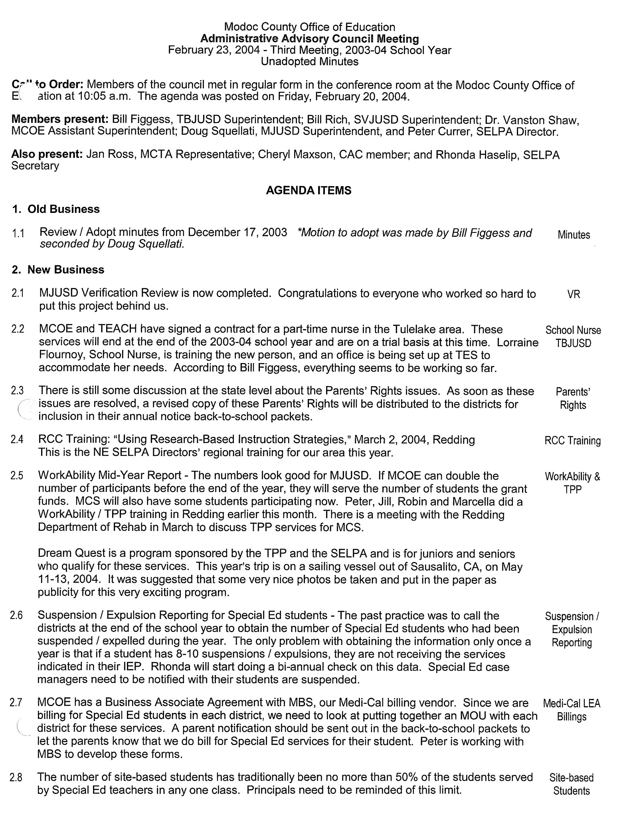

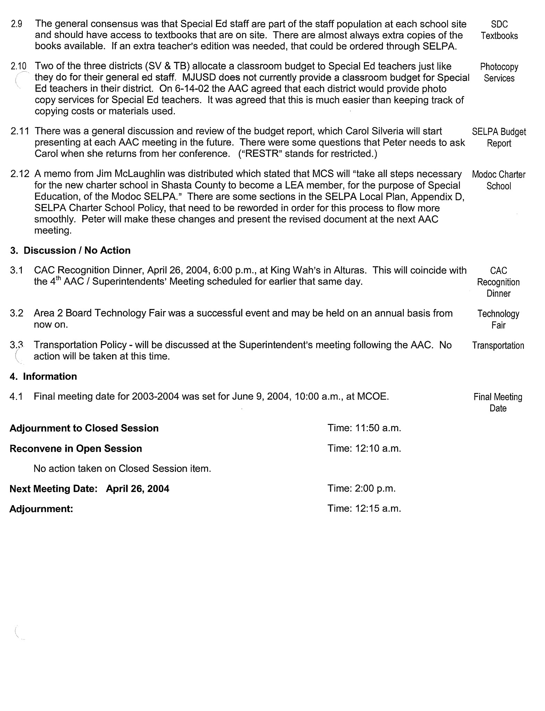

# MODOC COUNTY SELPA – Policy #

**RENTAL AGREEMENTS FOR SPECIAL EDUCATION CLASSROOMS**

**(see the following pages)**

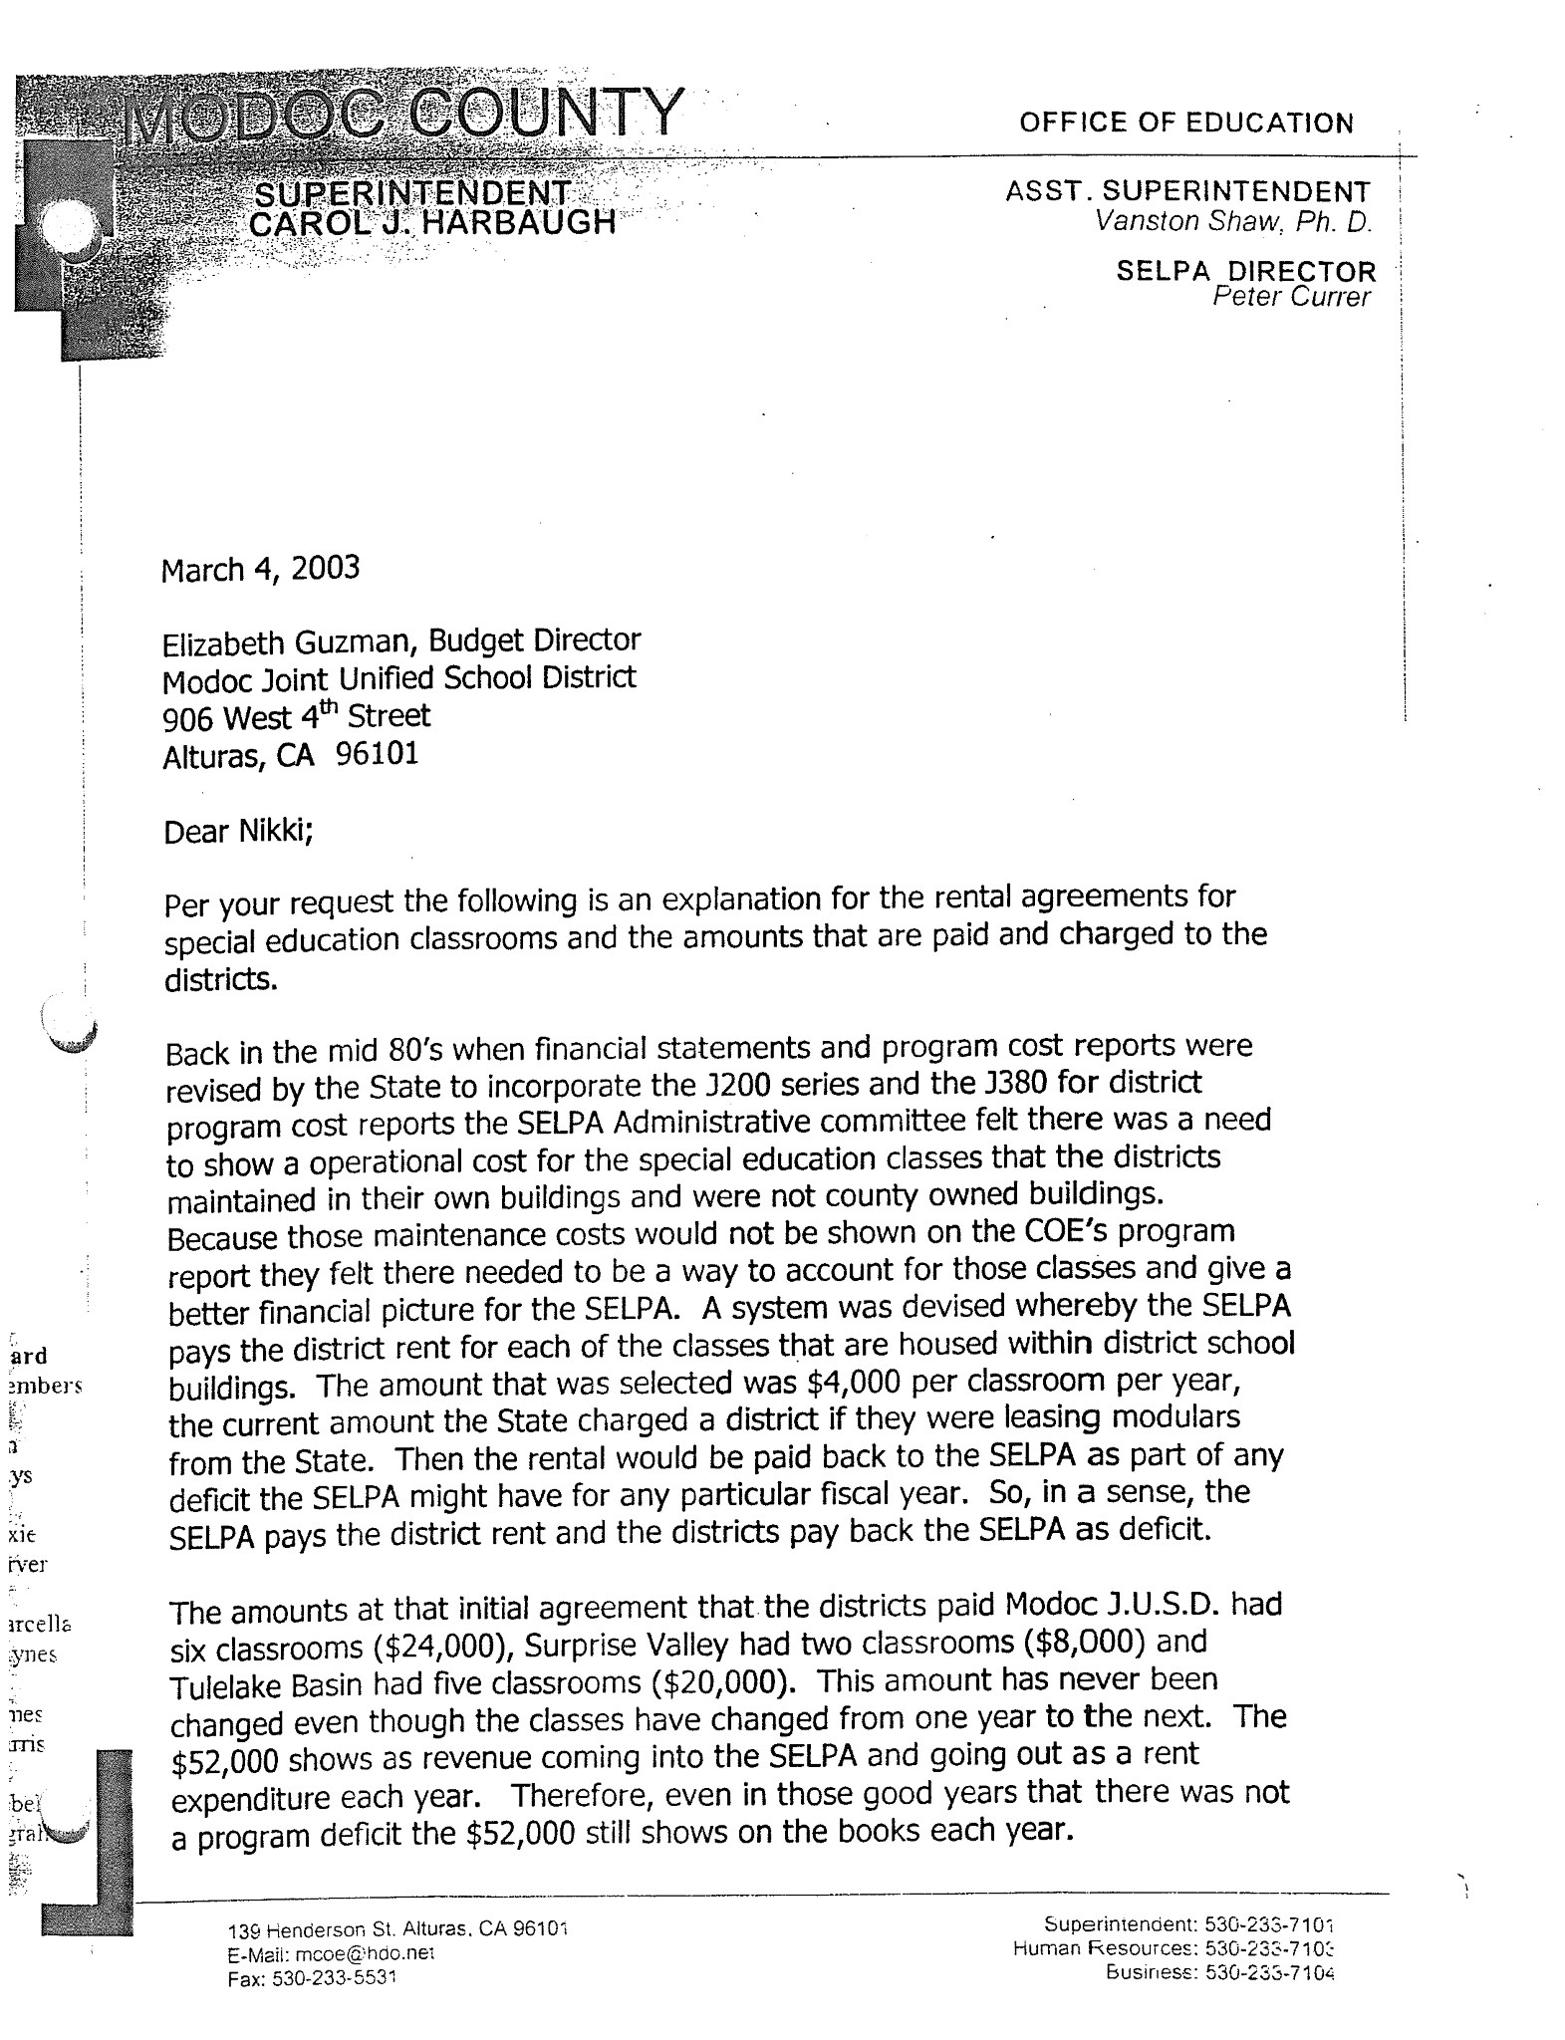

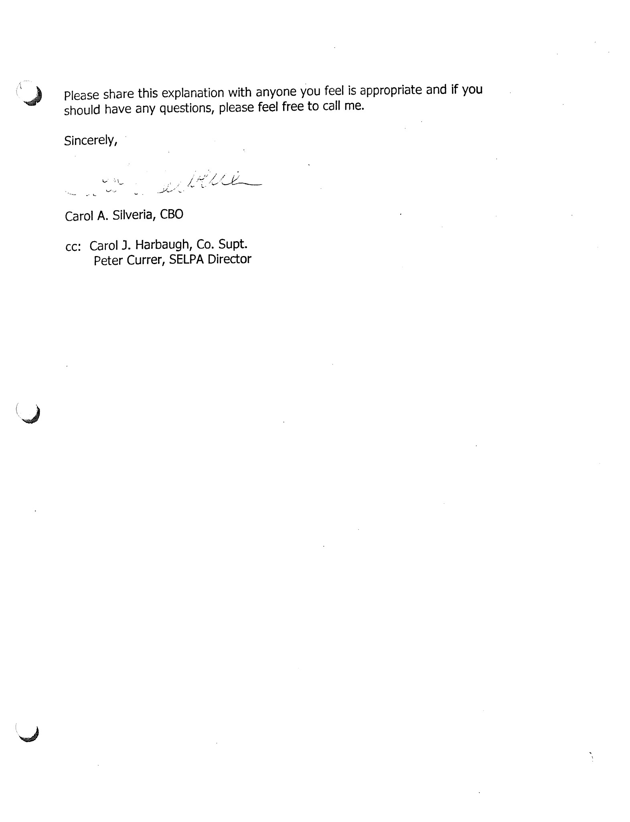

# MODOC COUNTY SELPA – Policy #7

**Independent Educational Evaluations Policy**

The following policy/procedures and criteria govern requests for independent educational evaluations at public expense. (20USC 1415; EC 56506(c) and EC 56329(b); 34 CFR 300.502) Parents should be sure to read the entire document carefully. The Policy/Procedures and Criteria are intended to be read in conjunction with one another as one comprehensive document. Parents who need additional information about independent educational evaluations should contact the SELPA Director of the Modoc County SELPA or contact the California Department of Education as outlined in their notice of Procedural Safeguards.

Notice to Parents

* Please read this document before obtaining or paying for an independent educational evaluation. This document may limit your right to reimbursement.
* Before obtaining an independent educational evaluation, please contact your local SELPA’s special education administrator to discuss your assessment questions and options.
* The local education agency will not automatically reimburse parents who unilaterally obtain independent educational evaluations. Please review this document for further information about a parent’s right to obtain independent educational evaluations at public expense.
* An independent educational evaluation, if not obtained in accordance with SELPA policy/procedures and criteria, may not be considered by you child’s IEP team. Please ensure that any independent educational evaluation conforms to SELPA requirements.

Definitions

“Independent educational evaluations” means an evaluation conducted by a qualified examiner who is not employed by the responsible local education agency.

“Public expense” means the local education agency either pays for the full cost of the evaluation or evaluation components or ensures that the evaluation or evaluation components are otherwise provided at no cost to the parent.

Parameters for Seeking Independent Educational Evaluations

If a parent disagrees with an evaluation conducted by the local education agency and seeks an independent educational evaluation, the local education agency will either initiate a due process hearing to show that its evaluation is appropriate or will provide the parent an opportunity to obtain an independent education evaluation in accordance with this policy by arranging for the independent evaluation. The parent must first inform the SELPA in writing or communicate with the SELPA at an IEP meeting that the parent:

1. Disagrees with the SELPA’s evaluation, and
2. Is requesting an independent educational evaluation at public expense.

*\*Note: The parents must request an independent evaluation within 6 months of the date that the results of the SELPA evaluation were shared with the parents.*

Explanation of Disagreement

If parents request an independent educational evaluation at the expense of the SELPA, the parents will be asked for a reason why they object to the SELPA’s evaluation. However, the SELPA may not unreasonably delay completion of a new assessment, completion of the independent educational evaluation at public expense, or the initiation of a due process hearing to defend its evaluation. There is no requirement that the parents specify areas of disagreement with the SELPA’s evaluation as a prior condition to obtaining the independent educational evaluation.

Response to a Request for an Independent Educational Evaluation

If parents request an independent educational evaluation at public expense, the SELPA will, without unnecessary delay, offer the parent an alternative examiner (Option 1 below) and also provide options for an independent educational evaluation at public expense (Options 2, 3 or 4 below) as follows:

1. A staff member from another school;
2. A staff member from another LEA in the SELPA;
3. A staff member from another SELPA; or
4. A private sector provider

Once the parent chooses an option, the SELPA will arrange for the alternative evaluator, contract with an independent examiner, or otherwise ensure that an independent educational evaluation is provided at public expense.

If the SELPA initiates a hearing and the final decision is that the SELPA evaluation is appropriate, the parent still has the right to an independent educational evaluation, but not at public expense.

Timeline Regarding Independent Educational Evaluations

In the interest of consistency between public and private evaluations, the SELPA encourages parents to choose an option for additional assessment offered by the SELPA within 15 days of receiving the options.

After the parent of the student with a disability chooses an option for an additional evaluation and signs an assessment plan, the SELPA will arrange for or initiate a contract with an appropriate evaluator.

The SELPA will make arrangements for a new evaluation, or contract with a qualified independent examiner who is able to provide a written report for an IEP meeting within 50 days of receipt of parent consent for assessment. If the evaluator cannot meet the required timeline, the SELPA will inform the parent and ask for agreement to an extension of time or selection of another option.

Information Provided to Parents

Upon parent request for an independent educational evaluation, the SELPA will provide the parents with a copy of its policy/procedures and criteria for independent educational evaluations.

Consideration of the Independent Educational Evaluation

Independent educational evaluations are designed to determine the educational needs of disabled students. The SELPA is responsible for determining placement and services. Therefore, the SELPA will consider recommendations obtained in independent educational evaluation reports completed in accordance with this policy/procedures and criteria. However, independent educational evaluations will not control SELPA determinations and may not be considered if not completed by a qualified professional as described in the attached criteria for educational evaluations.

Parent Initiated Evaluations

If the parents obtain an independent educational evaluation at private expense, the results of the evaluation:

1. Must be considered, if it meets the SELPA’s criteria, in any decision made with respect to the provisions of a free appropriate education to the student; and
2. May be presented as evidence at a due process hearing regarding that student.

Evaluations Ordered by Hearing Officers

If a hearing officer orders an independent educational evaluation as part of a hearing, the cost of the evaluation will be at the SELPA’s expense.

Modoc County SELPA Criteria

1. If an independent educational evaluation is at the SELPA’s expense, the criteria under which the evaluation is obtained, including the location, minimum qualifications of the examiner, cost limits, and use of approved instruments must be the same as the criteria that the SELPA uses when it initiates an evaluation.
2. As part of an independent educational evaluation at SELPA expense, the examiner shall follow guidelines for SELPA evaluations, which includes, but is not limited to, observing the student in an appropriate setting. The independent examiner shall attend the IEP team meeting in person or by phone at which time the evaluation will be discussed. The SELPA will pay the independent examiner to attend the IEP team meeting as part of the evaluation responsibilities, which also includes a classroom visitation and interviews with parents and staff.

Circumstances Affecting Reimbursement for Independent Educational Evaluations

Because the parent must first disagree with the SELPA’s evaluation in writing, the SELPA does not have an obligation to reimburse parents for privately obtained evaluations obtained prior to the date that the SELPA evaluation is completed and discussed at an IEP meeting. The SELPA is not obligated to reimburse parents for privately obtained evaluations if the parent disagrees with the SELPA’s evaluation and independently seeks a private evaluation without first notifying the SELPA in writing of their disagreement with the SELPA’s assessment and requesting an independent educational evaluation from the SELPA except as provided below.

The SELPA may reimburse the parents for a privately obtained independent educational evaluation, even though the policy above was not followed, in any one (1) of the following three (3) circumstances:

1. All the following conditions have been met:

* The parent disagreed with the SELPA’s evaluation;
* The parentally obtained evaluation meets the SELPA criteria;
* The parent timely and upon request provides the SELPA with written consent to exchange information with the examiner;
* The parent timely provides a copy of the written evaluation report and all other documents/tests related to the report;
* The examiner attends the relevant IEP team meeting in person by phone to discuss his/her findings and provides protocols of all assessments to the SELPA.

1. The SELPA assessment has not been provided in compliance with law.
2. The privately obtained evaluation assessed the student in an area of suspected disability, which was not previously assessed by the SELPA.

Reimbursement will be in accordance with the Modoc County SELPA policy/procedures and criteria and in an amount no greater than the actual cost to the parents.

In all cases, if the SELPA initiates a due process hearing to demonstrate that the SELPA evaluation is appropriate, no reimbursement shall be made unless ordered by a hearing officer.

**SELPA Criteria for Independent Educational Evaluations**

Limitations on Location of Evaluators

Evaluators must be located within the Modoc County SELPA. Evaluators outside of this area will be approved only on an exceptional basis if the parents can demonstrate the necessity of using personnel outside the specified area.

Minimum Qualifications for Evaluators

Type of AssessmentQualifications

Academic Achievement Certified Special Education Teacher (Master’s Degree),

Licensed Educational Psychologist, or

School Psychologist (Credentialed)

Adaptive Behavior Licensed Educational Psychologist,

Certified Special Education Teacher (Master’s Degree), or

School Psychologist (Credentialed)

Assistive Technology Certified or Licensed Speech/Language Pathologist, or

Certified Special Education Teacher (Master’s Degree)

Auditory Acuity/ Licensed or Certificated Audiologist

Auditory Perception (CAP) Licensed or Certificated Audiologist

Cognitive Licensed Educational Psychologist or

School Psychologist (Credentialed)

Motor Licensed Physical Therapist,

Registered Occupational Therapist, or

Adaptive Physical Education Specialist (Master’s Degree)

Speech and Language Certified or Licensed Speech/Language Pathologist

Social/Emotional/Behavioral School Psychologist (Credentialed),

Social Worker (LCSW),

Licensed Psychiatrist,

Licensed Educational Psychologist, or

Certified Behavior Analyst

Functional Vision Certified Teacher of the Visually Impaired (Master’s Degree)

Minimum Qualifications for Evaluators – continued

Visual-Motor Integration School Psychologist (Credentialed) or

Licensed Educational Psychologist

Note: Evaluators must be free from any conflict of interest.

Independent evaluators must agree to release their assessment information and results to the SELPA prior to receipt of payment for services. The results of the independent evaluation will be considered in the diagnosis, program decisions and placement of the student with disabilities as required by the Individuals with Disabilities Act.

Cost Limitations

Reimbursement for independent educational evaluations will be limited to the amount it would have cost the SELPA to provide the same type of evaluation. Costs in excess of this amount will not be approved unless the parent can demonstrate that such costs reflect a reasonable and customary rate for such evaluative services, or if the parents can demonstrate that there are other factors that make the extraordinary costs necessary.

Costs beyond the independent educational evaluation (i.e. transportation, lodging, food, etc.) are not covered in the cost of the independent evaluation and will not be approved, unless the parent can document that such travel costs reflect factors that make the extraordinary costs necessary.

# MODOC COUNTY SELPA – Policy #8

**SELPA MONITORING RESPONSIBILITIES**

Education Code Section 56195.7 requires development of written agreements to be entered into by the entities participating in the Local Plan for Special Education, which include regionalized services to local programs. Among the regionalized services is the provision for ongoing review of programs conducted, and procedures utilized, under the local plan, and a mechanism for correcting any identified problem.

SELPA monitoring activities to meet the Education Code requirement specified above may include, but not be limited to, the following:

* Observation of special education programs operated by each SELPA local education agency (LEA)
* Annual review of Individualized Education Program documents developed by LEA IEP Teams
* Analysis of LEA KPI data
* Review and analysis of LEA CASEMIS data
* Participation in the state’s Quality Assurance Process (i.e., Special Education Self Reviews, Verification Reviews and follow-up corrective action activities)
* Participation in selected LEA IEP Team meetings
* Review of selected LEA assessment reports
* Provision of ongoing training and technical assistance regarding compliant special education procedures

Correction of identified problems will be carried out through the following means:

* Consultation with the administrative personnel responsible for the LEA’s special education programs
* Provision of training and technical assistance as necessary to clarify compliant practices with appropriate LEA staff
* Assistance with correction of non-compliant student records, system non-compliant issues, procedures or practices identified through state or local compliance or complaint investigations

An ongoing self-review process will be instituted in Modoc SELPA to insure ongoing special education compliance.

In cases where the identified problem persists following implementation of the steps as outlined above, the LEA Superintendent shall be notified regarding the issue.

# MODOC COUNTY SELPA – Policy #9

**BEHAVIORAL INTERVENTION**

**(see complete manual on MCOE website under AAC)**

**MODOC COUNTY SELPA – Policy #10**

**Manifestation Determination**

**Federal Assurance Administrative Regulation**

**Suspension / Expulsion**

These procedures are designed to provide support to Local Education Agencies (LEA) in the Modoc County SELPA in determining appropriate options in the discipline of students with disabilities. This policy does not supersede LEA policies and procedures with respect to Board Policies on Discipline, Suspension or Expulsion. It is designed to provide support to school LEAs that may choose to use the procedures outlined in this document.

A student identified as an individual with disabilities pursuant to the Individuals with Disabilities Education Act (IDEA) is subject to the same grounds for suspension and expulsion which apply to students without disabilities.

**Procedures for Students Not Yet Eligible for Special Education Services**

A student who has not been officially identified as a student with disabilities pursuant to IDEA and who has violated the LEA’s code of student conduct may assert the procedural safeguards granted under this administrative regulation *only if* the LEA had knowledge that the student had a disability before the behavior that precipitated the disciplinary action occurred. (CCR 300.534 (a))

The LEA shall be deemed to have had knowledge that the student has a disability if before the behavior that precipitated the disciplinary action: (CCR 300.534 (b))

1. The parent or guardian expressed concern to supervisory or administrative personnel of the LEA, or a teacher of the child, in writing that the student is in need of special education related services; or
2. The parent or guardian requested an evaluation of the student for special education pursuant to federal regulations; or
3. The teacher of the student or other LEA personnel expressed specific concerns directly to the LEA’s director of special education or other supervisory LEA personnel about a pattern of behavior demonstrated by the student.

The LEA would be deemed to not have knowledge that a student is disabled if the parent or guardian has not allowed the student to be evaluated for special education services or has refused services. In addition, the LEA would be deemed to not have knowledge if the LEA had conducted an evaluation and determined that the student was not an individual with a disability. When the LEA is deemed to not have knowledge of the disability, the student shall be disciplined in accordance with procedures established for students without disabilities. (CCR 300.534 (d))

If a request is made for an evaluation of a student during the time period in which the student is subject to disciplinary measures, the evaluation shall be conducted in an expedited manner. Until the evaluation is complete, the student shall remain in the educational placement determined by school authorities. (CCR 300.534 (d))

**Procedures for Identified Special Education Students**

**Suspension**

The Superintendent or designee may suspend a student with a disability for up to five (5) consecutive school days for a single incident of misconduct, and for up to twenty (20) school days in a school year, as long as the suspension(s) does not constitute a change in placement pursuant to federal regulations. If, for the purpose of adjustment, a pupil enrolls in or is transferred to another regular school, an opportunity school or class, or a continuation school or class, the total number of days of suspension shall not exceed 30 days. (EC 48903; EC 48911 (a))

Removal of a student is considered a change of placement if the removal is more than ten (10) consecutive days of the student has been subjected to a series of removals that constitute a pattern:

1. Because the series of removals total more than ten (10) school days;
2. Because the child’s behavior is substantially similar to the child’s behavior in previous incidents that resulted in the series of removals; AND
3. Because of factors such as the length of each removal, the total amount of time removed and the proximity of the removals to one another.

The principal of designee shall monitor the number of days, including portions of days that students with valid individualized education programs (IEP) have bee suspended during the school year. The principal or designee will determine on a case-by-case basis whether a suspension beyond ten (10) cumulative days constitutes a change of placement. (CFR 300.536)

**Services During Suspension**

The LEA will treat special education students in the same manner as general education students during the first ten (10) cumulative days of suspension in a school year. Any student suspended for more than ten (10) school days in a school year shall continue to receive services during the term of the suspension. The extent and location of services provided will be dependent on whether the removal constitutes a change of placement as defined above.

If a student with disabilities is excluded from school bus transportation, the student shall be provide with an alternative form of transportation at no cost to the student / parent / guardian, provided that transportation is specified in the student’s IEP. (EC 48915.5)

**Requirements When Removals DO NOT Constitute a Change of Placement**

The principal or designee, in consultation with at least one of the child’s teachers, will determine the extent to which services are needed so as to enable the child to continue to participate in the general education curriculum, although in another setting, and to progress toward meeting the goals in the child’s IEP. The principal or designee, child’s teacher and relevant members of the IEP team will consider the need to develop or review the child’s behavior plan and, if necessary, schedule an IEP meeting for this purpose.

**Requirements When Removals DO Constitute a Change of Placement**

**Manifestation Determination**

On the date on which the decision is made to make a removal which constitutes a change in placement, the LEA must notify the parent or guardian of that decision and provide the parent or guardian with a Notice of Procedural Safeguards. Within ten (10) school days of the decision to make a change in placement, the LEA, parent or guardian, and relevant members of the IEP Team (as determined by the LEA *and* the parent or guardian) shall meet and review all relevant information in the student’s file, including the child’s IEP, any teacher observations, and any relevant information provided by the parent or guardian to determine:

1. If the conduct in question was caused by, or had, a direct and substantial relationship to the child’s disability; OR
2. If the conduct in question was the direct result of the LEA’s failure to implement the IEP.

If either of the previous conditions is found to be true, the behavior shall be determined to be a manifestation of the student’s disability. If neither condition is met, the behavior is not a manifestation of the student’s disability.

**Procedures if the Behavior IS NOT a Manifestation of the Student’s Disability**

If the manifestation determination review team determines that the student’s behavior was not a manifestation of his / her disability, the student may be disciplined in accordance with the procedures for students with disabilities. The student shall continue to receive services to the extent necessary to participate in the general education curriculum, although in another setting,   
and to progress toward meeting the goals set out in the student’s IEP. The decision regarding the extent and location of services during the removal will be determined by the IEP team. If the parent or guardian disagrees with the findings of the IEP team, they may file for a due process hearing as described in the Due Process Appeals section of this policy.

**Procedures if the Behavior IS a Manifestation of the Student’s Disability**

When the behavior is found to be a manifestation of the student’s disability, the IEP Team must:

1. Either conduct a functional behavior assessment and develop a behavior intervention plan OR, when a behavior plan has already been developed, review the current behavior intervention plan and modify it as necessary; AND
2. Return the student to the placement from which the child was removed, *unless the parent and LEA agree to a change of placement*.

**Exceptions to the Manifestation Determination Requirement**

School staff may remove a student to an interim alternative educational setting for not more than *forty-five (45) school days* without regard to whether the behavior is determined to be a manifestation of the child’s disability, when the student commits one of the following acts at school, on school premises, or at a school function under the jurisdiction of the LEA:

1. Carries or possesses a weapon, as defined in 18 USC 930 (G)(2).
2. Knowingly possesses or uses illegal drugs.
3. Sells or solicits the sale of a controlled substance as defined in 21 USC 812 (c).
4. Has inflicted serious bodily injury upon another person as defined in 18 USC 1365 (h)(3).

The interim alternative educational setting shall be determined by the IEP Team. (CFR 300.530 (5)) If the parent or guardian does not agree with the decision of the IEP Team, the parent or guardian may file for a due process hearing as described in the Due Process Appeals section of this policy.

**Expulsion**

If the IEP Team determines that the behavior in question is not a manifestation of the student’s disability, the LEA Governing Board may continue with expulsion proceedings. In the event of an expulsion, the Governing Board will determine the placement and all other aspects of the expulsion for a special education student in the same manner that it does for students who are not disabled. When a special education student is expelled, the IEP Team will meet to determine the extent of services necessary to enable the student to appropriately progress in the general curriculum, although in another setting, and appropriately advance toward achieving the goals set out in the student’s IEP.

**Services During Expulsion**

Any student with a disability who is expelled shall continue to receive services during the term of the expulsion to the extent necessary to provide the student a free and appropriate public education. Any alternative program must provide services to the extent necessary to enable the student to appropriately progress in the general curriculum, although in another setting, and appropriately advance toward achieving the goals set out in the student’s IEP. (20 USE 14121 (a)(1)(A); 34 CFR 300.530 (d)(5))

**Readmission**

Readmission procedures for students with disabilities shall be the same as those used for all students. Upon readmission, an IEP Team meeting shall be convened.

**Suspension of Expulsion**

The Governing Board’s criteria for suspending the enforcement of an expulsion order shall be applied to students with disabilities in the same manner as they are applied to all other students. (EC 48917)

**Notification to Law Enforcement Authorities**

Prior to the suspension of expulsion of any student with a disability, the principal or designee shall notify appropriate city or county law enforcement authorities of any act of assault with a deadly weapon which may have violated Penal Code 245. (EC 48902)

Within one (1) school day after a suspension or expulsion of a student with disabilities, the principal or designee shall notify appropriate city or county law enforcement authorities, by telephone or other appropriate means, of any act by the student which may violate EC 48900 (c) or (d), relating to the possession, use, offering or sale of controlled substances, alcohol or intoxicants of any kind. (EC 48902)

**Due Process Appeals**

If the parent or guardian disagrees with the determination that the student’s behavior was not a manifestation of his / her disability or with any decision regarding placement, the parent or guardian has a right to appeal the decision to a hearing officer. (20 USC 1415(k)(3); 34 CFR 300.532)

If the student’s parent or guardian initiates a due process hearing to challenge the interim alternative educational placement or the manifestation determination, the student shall remain in the interim alternative educational setting pending the decision of the hearing officer or the expiration of the 45-day time period, whichever occurs first, unless the parent or guardian and LEA agree otherwise. (20 USC 1415 (k)(4); 34 CFR 300.533)

If school personnel maintain that it is dangerous for the student to be placed in the current placement (placement prior to removal to the interim alternative educational setting) while the due process proceedings are pending, the Superintendent or designee may request an expedited due process hearing. (20 USC 1415 (k)(4); 34 CFR 300.532)

**Legal References**

**EDUCATION CODE**

489090-48925 Suspension and Expulsion

56000 Special Education; Legislative Findings and Declarations

56320 Educational Needs; Requirements

56321 Development or Revision of Individualized Education Program

56329 Independent Educational Assessment

56340-56347 Individualized Education Program Teams

56505 State Hearing

**UNITED STATES CODE, TITLE 20**

1412 State Eligibility

1415 Procedural Safeguards

**CODE OF FEDERAL REGULATIONS**

CFR 300-530-300.536

# MODOC COUNTY SELPA – Policy #11

**Provision for Ongoing Review of Programs**

SELPA Monitoring

ED CODE 56195.7(c)(6) Provisions for ongoing review of programs conducted and procedures utilized, under the local plan, and a mechanism for correcting any identified problem.

The Modoc County Special Education Local Plan Area (SELPA) will conduct SELPA monitoring of the Local Education Agencies (LEA) on a rotating yearly basis, with all LEAs being reviewed at least every three years. The Modoc County SELPA monitoring will be based on the State Level Special Education Review Process. State Level Special Education Self Review (SESR) monitoring on the fourth year of the rotation will replace the local monitoring.

The Modoc County SELPA is scheduled for SESR during the 2006-07 school year and every fourth year from that date forward.

SELPA staff will review records at one or more LEAs each year. This review will consist of the following:

1. Compliance questions generated from the California Department of Education, Special Education Division Verification Review Process as a Record Review.
2. Utilization of the “Summary of Non-Compliant Finding” form to record areas of concern.
3. Utilization of the “Educational Benefit Review Student Summary Form” to determine compliance with Educational Benefit.
4. A written report on findings delivered to LEA administration within four weeks of review.
   1. Listing of non-systemic findings and corrections necessary
   2. Listing of systemic findings and corrections necessary
   3. Educational Benefit findings and corrections necessary

SELPA staff will work with the LEA to correct the findings within a 6-month period of time.

For Record Review, there will be ten records for each LEA. The Educational Benefit Review will consist of three student records.

Records for Educational Benefit will be pulled from students who have already been reviewed as part of the Record Review portion of the SELPA monitoring.

# MODOC COUNTY SELPA – Policy #12

**ANIMALS AT SCHOOL**

The Modoc County SELPA recognizes that animals can be an effective teaching aid, and that animals may perform vital service functions for students with disabilities enrolled in Modoc County SELPA programs or for Modoc County SELPA staff and school visitors with disabilities. In addition, instruction related to the care and treatment of animals teaches students a sense of responsibility and promotes the humane treatment of living creatures.

Animals may be brought to Modoc County SELPA classrooms for educational purposes, or as service animals, subject to rules and precautions specified in the administration regulations of this policy. Site Administrators and teachers shall ensure that these rules and precautions are observed so as to protect students, staff, visitors, and animals.

The Modoc County SELPA assumes no liability for the animals brought into the classrooms.

*cf:* 0410 Nondiscrimination in District Programs and Activities

5131.1 Bus Conduct

5141 Health Care and Emergencies

5141.22 Infectious Diseases

Legal Reference:

EDUCATION CODE

233.5 Instruction in kindness to pets and humane treatment of living creatures

51202 Instruction in personal and public health and safety

51540 Safe and humane treatment of animals at school

GOVERNMENT CODE

810-006.6 California Tort Claims Act, especially:

815 Liability for injuries, generally: immunity of public entity

835 Conditions of liability

Management Resources:

Humane Society of the United States, Catalogue of Publications, 1996

Humane Society of the United States, *Guidelines for the Study of Animals in Elementary and Secondary School Biology*, HE 1079

Keenan and Associates, *Animals in the Classroom*, Copyright 2008

# MODOC COUNTY SELPA – Policy #13

**ADULTS IN CORRECTIONAL FACILITIES**

Free Appropriate Public Education (FAPE)

Every individual with exceptional needs who is eligible to receive special education instruction and related services under the Individuals with Disabilities Education Act (IDEA) and state special education laws, shall have access to that instruction and those services at no cost, as appropriate, to him or her. FAPE shall be available to individuals with exceptional needs in accordance with Section 1412(a)(1) of Title 20 of the United States Code and Section 300.101 of Title 34 of the Code of Federal Regulations.

Eligible Adults

Adults who are aged 18 through 21 years, who have not graduated with a high school diploma, who, at the time they turned 18 were identified as an individual with exceptional needs and had an individualized education program (IEP) under the IDEA, are also entitled to a FAPE (hereinafter referred to as “eligible adults”). (*See* 20 U.S.C. § 1400 (d)(1)(A), (B), (C); 20 U.S.C. § 1412 (a)(1)(A); California Ed Code §§ 56000, 56026(c)(4)) This applies to adults incarcerated in California adult jails and prisons. However, an individual aged 18 through 21 years, who, in the educational placement prior to his or her incarceration in an adult correctional facility was not identified as an individual with exceptional needs or did not have an IEP under the IDEA, is not entitled to FAPE. (20 U.S.C. § 1412 (a)(1)(B); California Ed Code § 56040(b))

District of Residence

California Ed Code § 56041 sets forth the responsibility for the provision of FAPE to eligible students aged 18 through 21 years.

“56041. Except for those pupils meeting residency requirements for school attendance specified in subdivision (a) of Section 48204, and notwithstanding any other provision of law, if it is determined by the individualized education program team that special education services are required beyond the pupil's 18th birthday, the district of residence responsible for providing special education and related services to pupils between the ages of 18 to 22 years, inclusive, shall be assigned, as follows:

(a) For nonconserved pupils, the last district of residence in effect prior to the pupil's attaining the age of majority shall become and remain as the responsible local educational agency, as

long as and until the parent or parents relocate to a new district of residence. At that time, the new district of residence shall become the responsible local educational agency.

(b) For conserved pupils, the district of residence of the conservator shall attach and remain the responsible local educational agency, as long as and until the conservator relocates or a new one is appointed. At that time, the new district of residence shall attach and become the responsible local educational agency.”

Child Find

The SELPA shall actively and systematically seek out all eligible adults incarcerated within its boundaries. The SELPA shall ensure that they are identifying and providing a FAPE consistent with this policy. Referrals can be submitted to the SELPA.

Individualized Education Program

The SELPA shall be the provider of services identified in the FAPE offer as described below. If the eligible adult consents to receive services, the SELPA will work with the correctional facility staff to offer services to the eligible adult student with disabilities, consistent with IDEA and corresponding California regulations.

Once the SELPA is informed that an eligible adult is incarcerated in an adult correctional facility, they will determine whether the eligible adult requests to receive FAPE. If so, the SELPA will ensure that the eligible adult student is provided FAPE, pursuant to the IDEA and corresponding California regulations. The SELPA shall review and revise the individual’s IEP, as necessary, subject to the cooperation of the correctional facility where the eligible adult is located. The eligible adult must consent to the receipt of such services in order to receive said services while incarcerated.

Limitations

The following special education requirements do not apply to eligible individuals who are convicted as adults under State law and incarcerated in adult prisons:

1. The requirements set out in 20 U.S.C. § 1412(a)(16) and 20 U.S.C. § 1414(d)(1)(A)(i)(VI) (relating to participation in general assessments) do not apply. Eligible individuals convicted as adults under State law and incarcerated in adult prisons are exempted from participation in State and district-wide assessment programs under the IDEA.
2. The requirements of items (aa) and (bb) of 20 U.S.C. § 1414(d)(1)(A)(i)(VIII) (relating to transition planning and transition services), do not apply with respect to such individuals whose eligibility under the IDEA will end, because of their age, before such individuals will be released from prison.
3. If an individual with a disability is convicted as an adult under state law and incarcerated in an adult prison, the individual’s IEP Team may modify the individual’s IEP or placement, notwithstanding the least restrictive environment (LRE) requirements of 20 U.S.C. § 1412(a)(5)(A) and the IEP contents requirements of 20 U.S.C. § 1414(d)(1)(A), if there is a bona fide security or compelling penological interest that cannot otherwise be accommodated.

The SELPA can discontinue services provided under this policy upon request to the Administrative Advisory Council (AAC), the SELPA governance board. The request must be received by March 1 of the calendar year and becomes effective July 1 of the next school year. The AAC will determine how services shall be provided to these incarcerated adults in the future.

Legal Reference: 20 U.S.C. § 1414(d)(7); 34 C.F.R. §§ 300.102, 300.324(d); California Ed Code §§ 56040-56041; California Government Code § 7579(d); *Letter to Yudien*, 39 IDELR 270, 103 LRP 37913 (OSEP 2003)

# MODOC COUNTY SELPA – Policy #14

**CERTIFICATES OF COMPLETION**

Instead of a high school diploma, a student with disabilities may be awarded a certificate or document of educational achievement or completion from their district of residence, if the student has met one of the following requirements: (Education Code 56390)

1. Satisfactorily completed a prescribed alternative course of study approved by the board of the district in which the student attended school or the district with jurisdiction over the student as identified in his/her IEP
2. Satisfactorily met his/her IEP goals and objectives during high school as determined by the IEP team
3. Satisfactorily attended high school, participated in the instruction as prescribed in his/her IEP, and met the objectives of the statement of transition services

*(cf. 6146.1 – High School Graduation Requirements)*

A student with disabilities who meets any of the criteria specified above shall be eligible to participate in any graduation ceremony and any school activity related to graduation in which a graduating student of similar age without disabilities would be eligible to participate. (Education Code 56391)

*(cf. 5127 – Graduation Ceremonies and Activities)*

# MODOC COUNTY SELPA – Policy #15

**MODOC county SELPA ATTENDANCE PROCEDURES**

**FOR SPECIAL EDUCATION STUDENTS**

the Local Educational Agency (LEA) members of the Modoc County SELPA agree that Special Education students served by the Modoc County SELPA are students of the district of residence, not of the SELPA. These students and their education are the responsibility of their respective district of residence, which include Modoc County Office of Education, Modoc Joint Unified School District, Surprise Valley Joint Unified School District, and Tulelake Basin Joint Unified School District.

The Modoc County SELPA provides all Special Education services for students enrolled in the county office and/or districts listed above. These member LEAs of the SELPA agree that some Special Education students do require a higher, more costly level of individualized service than other Special Education students. Special Education students who spend 51% or more of their school day in a Special Education setting or require specialized instruction or supervision for this percentage of time, will be considered SDC students.

In order to financially support the provision of these more substantial services by the SELPA, member LEAs of the Modoc County SELPA agree to use the data from August 1 each year for collecting the SDC attendance for the entire school year. This SDC attendance will be reported to the Modoc County SELPA on a monthly basis.

All new incoming students with an IEP, or current students who are found eligible for Special Education during the year, will be on the LEA attendance for that entire school year.

Whichever LEA reports the student’s ADA, either the County Office or the District of Residence, that LEA will assume the responsibility for ordering the state testing materials.

Students who are on the SELPA enrollment and who exit Special Education during the school year will remain on the SELPA’s attendance through the following July.

# MODOC COUNTY SELPA – Policy #16

**MAINTENANCE OF EFFORT (MOE)**

The Modoc County Special Education Local Plan Area ("SELPA") shall meet Maintenance of Effort (MOE) regulations requiring the federal funds be used only to pay the excess costs of providing special education and related services to children with disabilities and to supplement and not supplant state and local funds for special education (ref: Title 34 Code of Federal Regulations CFR Section 300.203-300.205).

The SELPA Administrative Unit, as the grantee of federal funds from the State Department of Education, shall annually conduct and report to the State Education Agency (SEA) the required MOE information. If the Local Plan were to be revised so that individual LEAs within the SELPA receive allocations of federal dollars, each LEA would be required to submit the MOE calculation to the SELPA.

The two required comparison tests are as follows:

**First Comparison** – Grant year Budget to Prior Actual Expenditures (SEMB)

* The SELPA will complete the required MOE documentation each year.
* Budgeted local or state and local expenditures must equal or exceed prior year expenditures for the SELPA.

Section 1 - Each year, the SELPA should record any of the exceptions listed below:

1. These items will reduce the amount required to meet MOE:

* The voluntary departure or departure for just cause, of special education or related service personnel, who are replaced by qualified, lower-salaried staff
* A decrease in the enrollment of children with disabilities
* The termination of the obligation of the agency to provide a program of special education to a particular child with disabilities that is an exceptionally costly program because the child:
  1. Has left the jurisdiction of the agency
  2. Has reached the age at which the obligation of the agency to provide FAPE to the child has terminated; or
  3. No longer needs the program of special education
* The termination of costly expenditures for long-term purchases, such as the acquisition of equipment or the construction of school facilities

Section 2 – The SELPA who has met state requirements and has not been found to be significantly Disproportionate may also reduce their MOE requirement by:

1. Calculating 50 percent of the increase in federal funding received that year over the prior year as “local funds” (34 CFR Section 300.203)

Section 3 – MOE Test

1. Either local or state and local funding sources are used for comparison at the SELPA level.
2. When the capability exists to isolate “local only” funding sources the comparison may be made using only “local” resources.
3. Comparison may be either total amount or a per capita (per child with a disability unless some other basis is permitted by the SEA for determining “per capita”) basis (34 CFR Section 300.203)

**If the SELPA passes Comparison 1, the SELPA is eligible to receive Part B funding.**

**If the SELPA still fails Comparison 1, the SELPA will be ineligible to receive Part B funding until budgetary revisions are made to enable the SELPA to meet MOE requirements.**

**Second Comparison** – Prior Year Actuals vs. Second Prior Year Actuals (SEMA)

* Actual local or state and local expenditures must equal or exceed prior year expenditures
* Comparison is made after unaudited actuals data is submitted to CDE following the end of the fiscal year
* The comparison will occur annually

Section 1 - Each year the SELPA should record any of the exceptions listed below:

These items will reduce the amount required to meet MOE:

* The voluntary departure or departure for just cause, of special education or related service personnel, who are replaced by qualified, lower-salaried staff
* A decrease in the enrollment of children with disabilities
* The termination of the obligation of the agency to provide a program of special education to a particular child with disabilities that is an exceptionally costly program because the child:

1. Has left the jurisdiction of the agency
2. Has reached the age at which the obligation of the agency to provide FAPE to the child has terminated; or
3. No longer needs the program of special education

* The termination of costly expenditures for long-term purchases, such as the acquisition of equipment or the construction of school facilities

Section 2 – The SELPA who has met state requirements and has not been found to be significantly Disproportionate may also reduce their MOE requirement by:

Calculating 50 percent of the increase in federal funding received that year over the prior year as “local funds” (34 CFR Section 300.205)

Section 3 – MOE Test

1. Combined actual local or state and local funding sources are used for comparison at the SELPA level.
2. When the capability exists to isolate “local only” funding sources the comparison may be made using only “local” resources.
3. Comparison may be either total amount or a per capita (per child with a disability unless some other basis is permitted by the SEA for determining “per capita”) basis (34 CFR Section 300.203(c))

**If the Local Plan were to be revised and individual LEAs within the SELPA fail Comparison 2 after applying the exceptions, the LEA would be billed by the State for the amount the LEA failed to spend from local or state and local funds to maintain its level of effort.**

# MODOC COUNTY SELPA – Policy #17

**GRADUATION FROM HIGH SCHOOL**

Individuals with exceptional needs within the Modoc County Special Education Local Plan Area (SELPA), who graduate from high school with a regular high school diploma, will no longer be eligible for special education and related services, as provided in Section 300.102(a)(3)(i) of Title 34 of the Code of Federal Regulations.

A “regular high school diploma” means a diploma conferred on a pupil who has met all local and state high school graduation requirements.

“Regular high school diploma” does not include an alternative degree that is not fully aligned with the academic standards of the State of California, such as a Certificate or a General Educational Development Credential (GED).

Graduation with a regular diploma is a change of placement for Special Education students, thus requiring an IEP meeting to review the student’s program to ensure that graduation requirements will be met and that the goals and objectives in the IEP will be completed.

The district will send a Prior Written Notice to the parent/student within a reasonable amount of time before this change in placement. The notice will include: 1) a description of what the district intends to do; 2) an explanation of the reasons for the action; 3) a description of any alternatives the district considered and why those were rejected; and 4) a description of the reports, tests, and procedures on which the action is based. (See copy of Prior Written Notice attached.) Without this required notice, the district’s proposal to graduate a student may be inappropriate.

# MODOC COUNTY SELPA – Policy #18

**MODOC COUNTY SELPA ADA Transfer**

**FOR SPECIAL EDUCATION STUDENTS**

the ADA Transfer calculation is based on the former Revenue Limit calculation.

The dollar amount is calculated using the total Local Control Funding Formula (LCFF) entitlement minus the estimated total supplemental and concentration grants found on the summary page of the LCFF Calculator divided by the total ADA.